Initial User Instruction Manual

Game: Slot Machine

Players: One

Interface: Mouse, Keyboard

Goal:

Slot Machine is a game where you have 3 reels containing a variety of pictures printed on the surface of the reels: Cherry, Orange, Grape, Red 7, and Jackpot. The goal is to get the highest score before running out of coins.

Game Play:

The Instructions for how to play are displayed at the beginning of the game, and can be accessed during the game in the top left corner. The user receives an initial amount of coins which are spent in order to play the slot machine. The user clicks on a square slot in order to insert a coin, and must press a play box in order to start up the slot machine. The reels on the slot machine will move for a few seconds in a blur, move slowly on some images, and then stop on images which will either help the user earn coins, or gain no coins at all. A key will be provided to show the amount of coins earned depending on the sequence of the reels. Above the reels, a number is portrayed showing the Jackpot that can be won. The Jackpot number will increase after every spin that is not a Jackpot win.

Scoring:

The user initially has a score of 0 and a coin count of 10. When the user inserts a coin into the slot machine, the coin count will go down by one. Please NOTE that they are TWO different things. Whenever the user matches a sequence in the key after using a coin, the coin count and the score will both increase based on the number of coins that are won with a sequence. If the user wins the Jackpot, the user gets the score and coin amount of the Jackpot and the Jackpot prize resets to 10000.

Data:

The user may save his/her game anytime throughout the whole entire game. He/she must type in a name that the saved slot machine data will go under, and then he/she may continue playing. When a user starts playing, they can load a file under a name that they know or saved and it will put them back on the same amount of coins, score, and jackpot.

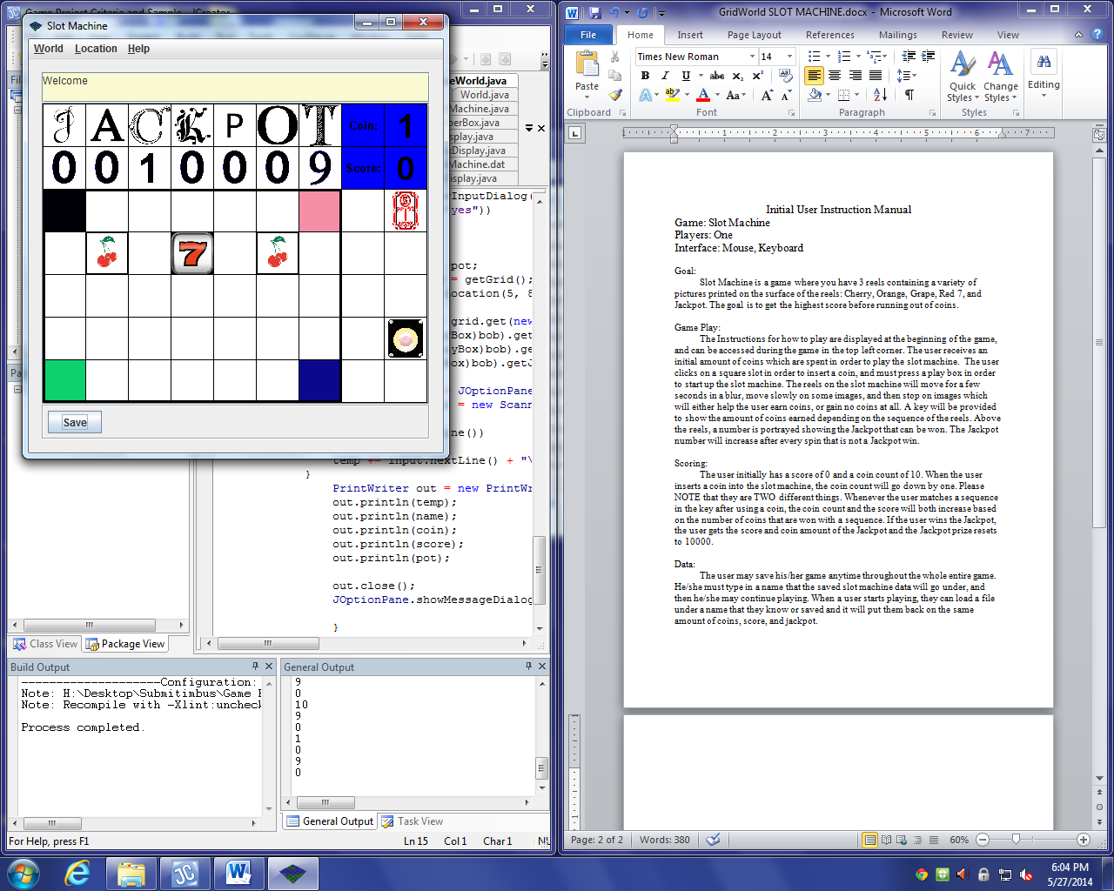State of Memory: Slot Machine

NumberBox:

Location(1,0)

value: 0

PlayBox:

Location(5,8)

pushable: false

jackpot: 10009

coinCount: 1

score: 0

win: false

frame:

CoinBox:

Location(2,8)

insertable: true

ScoreAmountBox:

Location(1,8)

score: 0

CoinAmountBox:

Location(0,8)

coinAmount: 1

Color: Blue

Direction:irrelevant

ScoreTextBox:

Location(1,7)

Color: Blue

Direction:irrelevant

CoinTextBox:

Location(0,7)

Color: Blue

Direction:irrelevant

LetterBox:

Location(0,0)

value: 0

LightBox:

Location(2,0)

value: 2

ReelBox:

Location(3,1)

value: 4

difficulty: 0